**Some photographs of study species with their magnitude**

***Mikania micrantha***

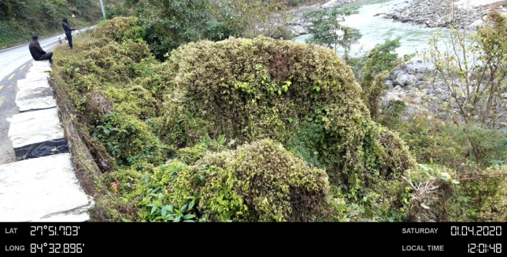 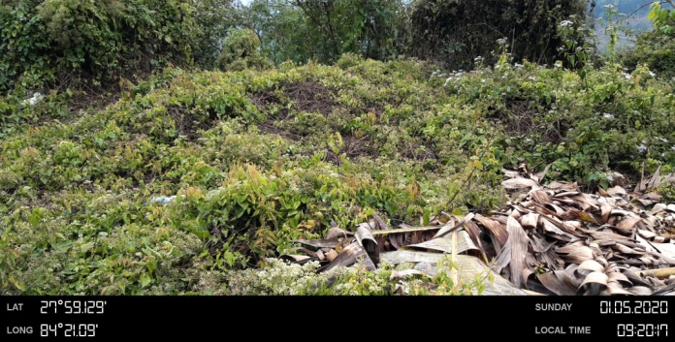

Moderate Low

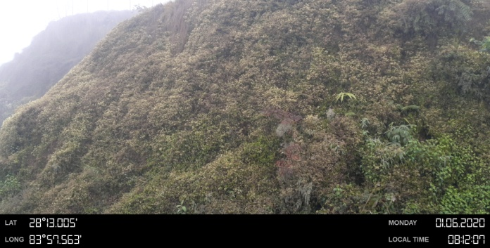 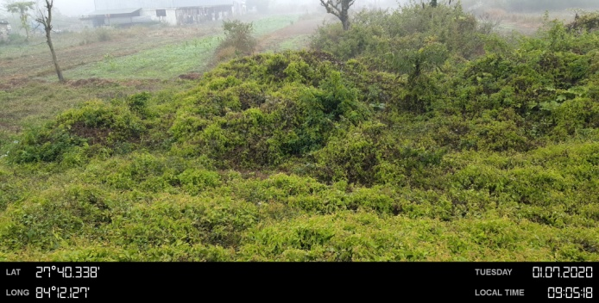

Dense Dense

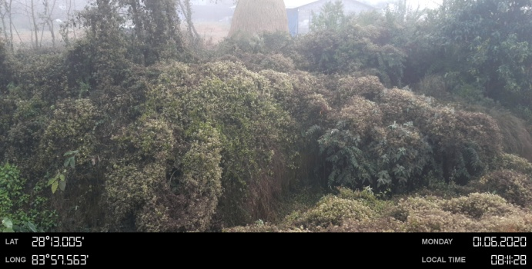 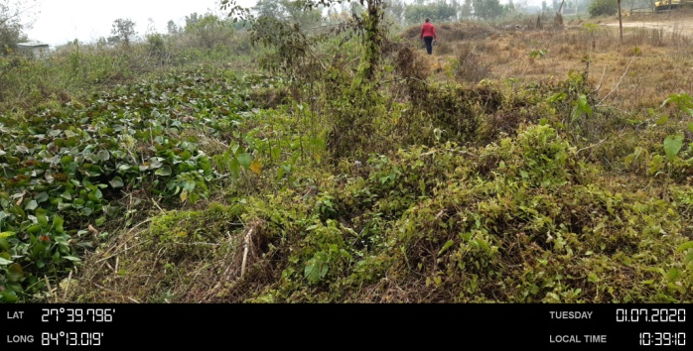

Dense Low

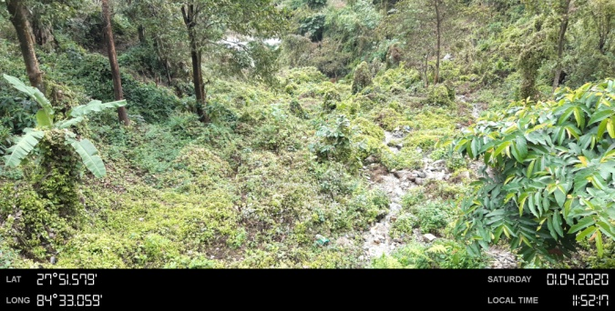 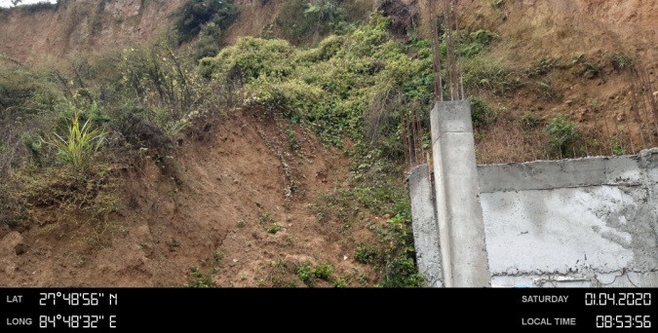

Moderate Low

***Chromolaena odorata***

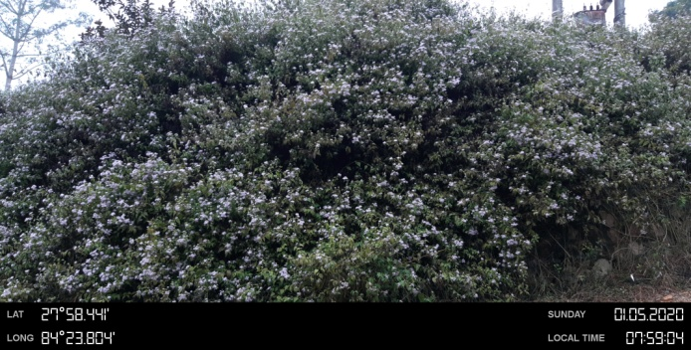 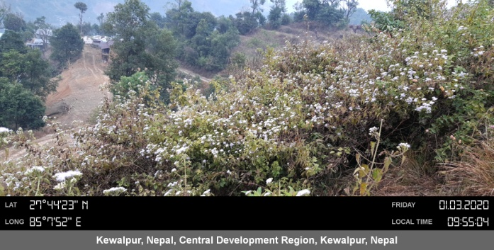

Dense Moderate

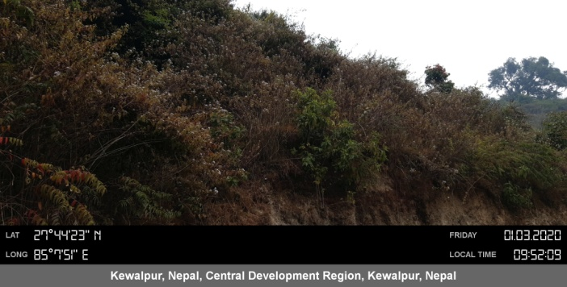 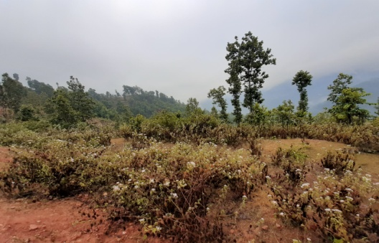

Moderate Low

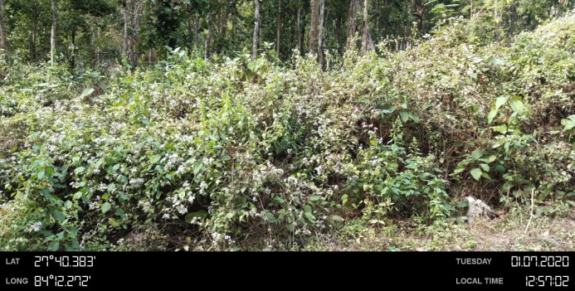 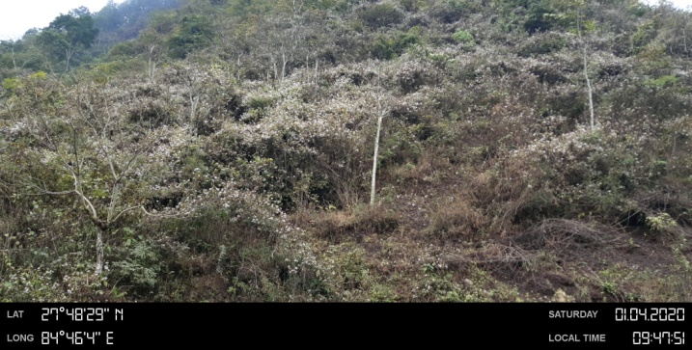

Low Dense

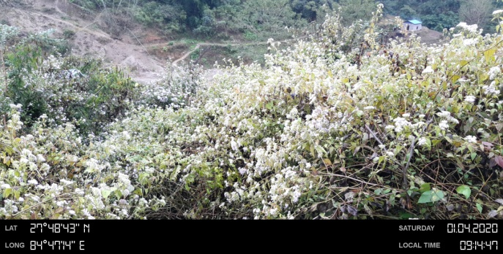 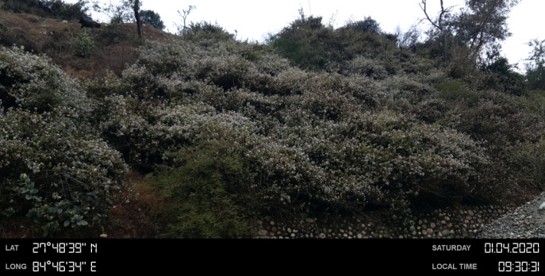

Moderate Dense

***Lantana camara***

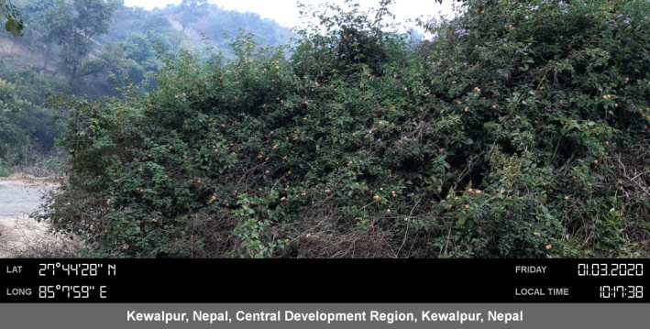 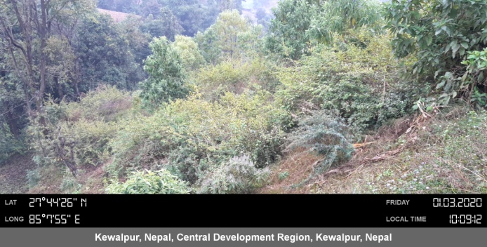

Moderate Low

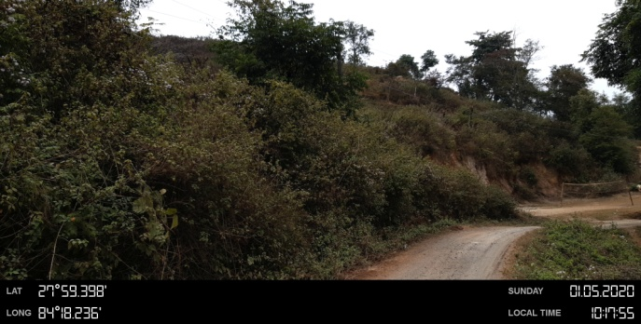 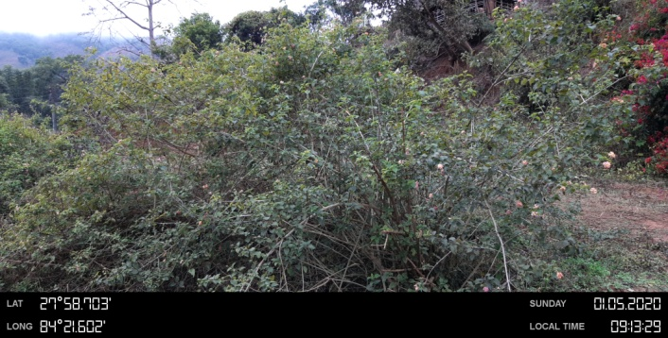

Moderate Low

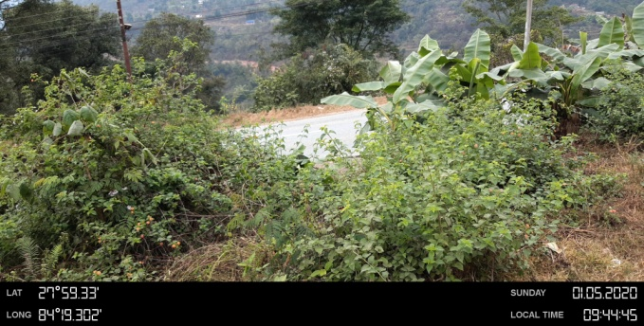 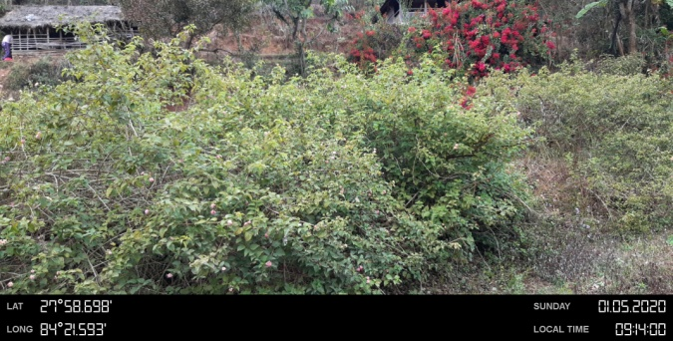

Low Moderate

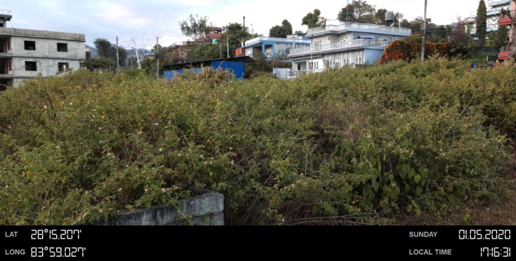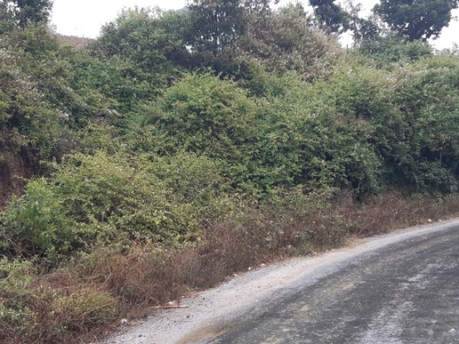

Dense Dense

***Eichhornia crassipes***

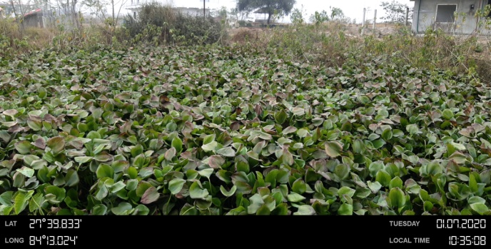 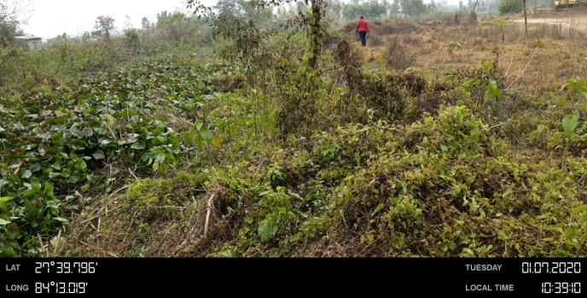

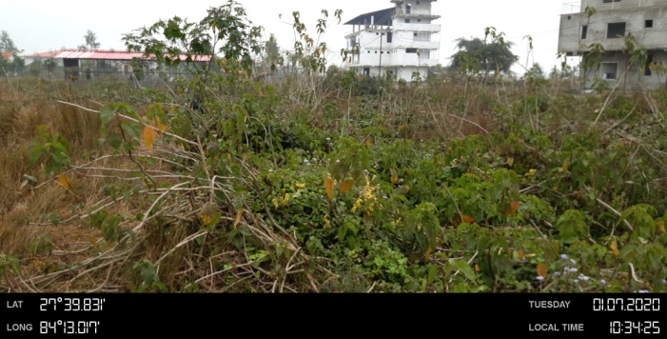

Low(*Eichhornia +Ipomea*)

**Note:**

Low: 2*2 (patch size)

Moderate: ≥ 5*5( Patch size)

Dense: ≥ 10*10

**Field Report**

We had started our five days field visit on 3rd January 2020 for Dhading,Tanahau, Gorkha, Kaski, Syangya, Nawalparasi, Chitwan and Makwanpur district as our study site. The field was mainly focused for the collection of geographic coordinate of the study species. Field visit was mainly based on the digital globe map of study sites. We visited most of the sites that were access to road as road is the dispersal pathway of invasive species. We found that most of sites of Dhading and Gorkha(Hill areas) are inavaded by *Chromolaena* also some sites of Makwanpur are densely invaded by *Chromolaena* in comparison to other species. However in case of Tanahau, Nawalparasi and Chitwan, invasion by *Lantana* was higher. Among all the sites, it was observed that sites of kaski was less inavaded by the invasive species. However the southern part i.e near the dumping side was heavily invaded by *Mikania* in few area. Large scene of Gorkha was unable to cover due to difficulty in road access. Large patch of *Eichhornia* was found on Dumkauli area of Nawalparasi. GPS location was mainly based on the patch size of the species. Patch size of 2*2m and above having the species coverage of more than 80% are considered for the GPS location (2*2=low, 5*5=moderate and 10*10=Dense) Most of the dense patches are of *Chromolaena* followed by *Lantana* and*Mikania.*